The
ABC’s
of
Room 123

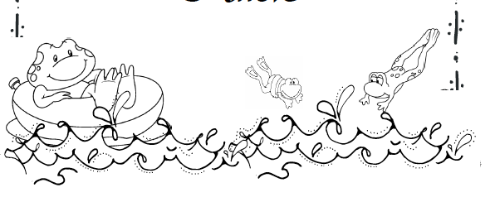

The ABC’s of Room 123
A
Attire
Room 123 is a busy place that sometimes can be messy! Dress your child so they are ready for action! We paint; we play with shaving cream, and play in sand… just to name a few!

B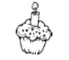
Birthdays
Birthdays are special occasions for young children. If your child wishes, s/he may bring in special treats to share with our class. These items must be store purchased. A birthday treat list with assigned treat day swill be passed out ASAP.

Book Orders
Throughout the year, your child will have the opportunity to order books through various book clubs. As you purchase books, our classroom will earn points that will allow us to earn free books; you may order at your own discretion. When ordering, please make checks payable to the book club listed on the form. Send in the check and order in an envelope with your child’s name and room number on it, by the date listed on the back of the form.

SIGN UP at www.Scholastic.com/bookclubs. On the parent page, click the “Don’t have a User Name and Password?” link, then register for your own username and password. When prompted, type in my name, Mrs. Courtney Diamond, which your order is sent to me.

C
Communication
I believe that a good parent-teacher relationship is very important to your child’s success in school. Throughout the year, I will communicate with you through notes, telephone calls, newsletters, and conferences. I encourage you to contact me any time with any questions or concerns. Feel free to send notes or email me (diamondc@tuscola.k12.il.us).

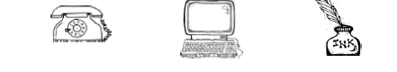
D
Discipline
The “North Ward Way”
- Be Respectful
- Be Responsible
- Be Safe

The children are required to follow the classroom rules.
- I will listen and follow directions.
- I will keep my hands and feet to myself.
- I will be kind to others.

Behavior charts and calendars…
We will use a Clip Chart in our classroom. Each student will have a clothespin with his or her name on it. Students will begin each day in the middle of the chart, on green. Students may be asked to move their clothespin up or down the chart during the day depending on their choices. Here is a model of the Clip Chart and what each space on the chart means:

Purple | You did it!  You hopped to the top! | Students who reach the purple level will be rewarded for their positive choices by receiving class recognition, a treat, a sticker to add to their clip and receive a special certificate of recognition.
Pink | High Hopper! | Students who continue to make positive choices move up to the purple level. They are having an awesome day and will receive class recognition and a treat!
Blue | Wow! | Students who make positive choices will receive class recognition as they move up the chart.
Green | Hoppy Learning! | Everyone starts the day with “Hoppy Learning!” students will “clip up” or “clip down” throughout the day depending on their behavior choices.
Yellow | Warning! | Students who receive a warning will move to yellow. This serves as a reminder to students to “take 2 and think” about the choices they make.
Orange | Danger! | Students who continue to make poor choices, will move to orange. This will result in a consequence.
Red | Oh NO! | Students that continue to make poor choices will move to red. This will result in parent contact and a consequence.

Parents will know their child’s behavior through the use of their FROG folder, there will be a behavior calendar on the left side of the folder that students will color corresponding with their clip. Please be sure to review your child’s behavior daily. Student’s who have 5 green, blue, pink, or purple days in a row will have the opportunity to take a prize from our treasure chest!

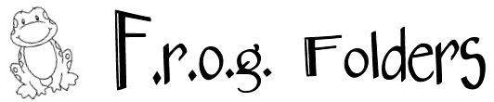
Each student will have a “Frog” folder to take home each night. Frog stands for, “For Really Organized Guys/Gals.” All students will have a folder with a frog cut-put taped to it.

It is absolutely necessary that your child’s folder be at school with them EVERYDAY! Please make sure it is always in their backpack.

This folder is to be used for communication and student work. Within this folder you will find… a monthly behavior calendar that is stapled to the left side. Any notes home, newsletters, notes from the office/teacher, etc., will be in this folder. Any notes you have for me, book orders, field trip slips, etc. should be placed in this folder. I will check these folders as soon as school begins.

When it is necessary to send money to school, ALWAYS send it in a sealed envelope with the following information on it…
Your child’s name
The purpose of the money
Our room number (123)
My name (Mrs. Diamond)
Money envelopes MUST be put inside the folder!!

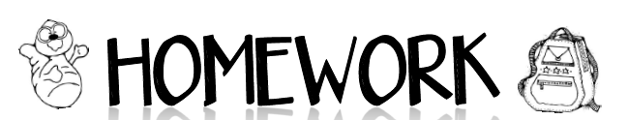
Homework will be used to reinforce the concepts we work on in class.

What needs to be turned in…
The family project MUST be turned in!

Family Project – Each month there is a family project that needs to be completed AND returned. I would like for the project to be worked on as a family. The projects range from decorating a school house to disguising a turkey. Have fun with these projects!!

L
Love
Above all else, we are here to love on your child! Thank you so much for entrusting your precious child with us! We cannot wait to get to know them and help them grow into an incredible person!

M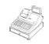
Money
When it is necessary to send money to school, ALWAYS send it in a sealed envelope with the following information on it…
Your child’s name
The purpose of the money
Our room number (123)
My name (Mrs. Diamond)

P
Parents
You are ALWAYS welcome within our classroom whether it is to help out or just spend some time within our room! Please give me a heads up when you plan on coming in!

Parties and Celebrations
Throughout the year we will have a variety of celebrations for Holidays and other milestones. Everyone is encouraged to participate!

Some things you can look forward to…
Halloween Party
Thanksgiving Feast
Pajama Party
Winter Party
Valentine Party
End of School Year Party

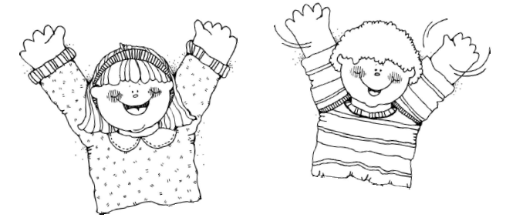

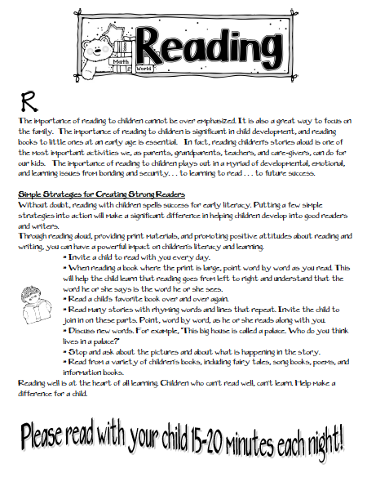
S
Snack
We will have snack everyday in our classroom. Please bring snack whenever you can! I will be sending home a calendar shortly.

PLEASE NOTIFY ME OF ANY FOOD ALLERGIES YOUR CHILD HAS!

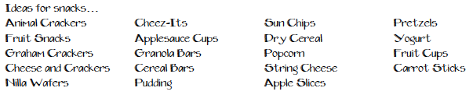

T
Transportation
If there is a change in routine transportation for your child, you MUST sent a written note. If a written note is not received, your child will be sent home by his/her usual method of transportation.

Toys
Bringing toys to school is discouraged because they distract the children from learning. If a toy is accidentally lost or broken, feelings will be hurt.

You are encouraged to visit and help out ANY time! You are also encouraged to be a Mystery Reader within our classroom. Just let me know if you are interested, and we will set up a date and time!

W
Website
Our class will have its very own website! You will be able to find out a lot of useful information there including; a listing of important dates, cool links, and downloads! I try to keep our homework calendars, newsletters, and Special notes uploaded on there.

http://mrsdiamondsfrogs.weebly.com/
X
eXceptional
Room 123 is a great place for your child to learn and grow! I will do EVERYTHING I possibly can to ensure that your child is safe, cared for, and is receiving the best possible education! We are going to have a wonderful year!!!
